Banking Transaction Analysis using SQL

Objective :
The main objective of the Banking Transaction Analysis project is to analyze customer accounts, banking transactions, loans, employees, and branch-level data using SQL.
The project aims to:
Analyze customer and account information to understand banking customer behavior.
Identify high-value customers based on account balances and transaction activity.
Analyze transaction patterns such as transaction volume and transaction amounts.
Evaluate branch performance based on customers, accounts, balances, loans, and transactions.
Analyze loan distribution and identify customers with significant loan amounts.
Identify the most popular account types and customer account patterns.
Use advanced SQL techniques such as JOINs, Aggregate Functions, Subqueries, CTEs, and Window Functions to solve real-world banking problems.
Generate meaningful insights that can help banks improve customer services, understand transaction behavior, and make better business decisions.

Business Problem
Banks generate large amounts of data from customers, accounts, transactions, loans, employees, and branches. Analyzing this data manually can be difficult and time-consuming.
The objective of this project is to develop a SQL-based analysis system that helps the bank understand its business performance and customer behavior.
The bank wants to answer important business questions such as:
- Who are the bank's highest-value customers?
- Which customers have the highest transaction activity?
- Which branch has the highest total account balance?
- Which branch performs best based on transaction activity?
- What are the most frequently used account types?
- What are the monthly transaction trends?
- Which customers have multiple accounts?
- Which customers have both loans and multiple accounts?
- Which loan types have the highest total loan amount?
- Which branches have the highest number of loans?
- Which accounts are inactive or have no transactions?
- How does transaction activity change over time?
By answering these questions using SQL, the bank can identify customer trends, evaluate branch performance, monitor account and transaction activity, and support data-driven business decisions.

Branches :
Column | Key | Description
Branch_ID | PK | Unique branch ID
Branch_Name |  | Branch name
City |  | Branch city
State |  | Branch state

Customers :

Column | Key | Description
Customer_ID | PK | Unique customer ID
First_Name |  | Customer first name
Last_Name |  | Customer last name
Branch_ID | FK | Customer's branch
... |  | Other customer details

Accounts :

Column | Key | Description
Account_ID | PK | Unique account ID
Customer_ID | FK | Account owner
Account_Type |  | Savings, Current, Salary, Fixed Deposit
Balance |  | Current account balance
Open_Date |  | Account opening date
Status |  | Active, Inactive, Dormant

Employees :

Column | Key | Description
Employee_ID | PK | Unique employee ID
Employee_Name |  | Employee name
Designation |  | Job designation
Salary |  | Employee salary
Branch_ID | FK | Employee's branch

Loans :

Column | Key | Description
Loan_ID | PK | Unique loan ID
Customer_ID | FK | Borrowing customer
Loan_Type |  | Home, Car, Personal, Education, Gold
Loan_Amount |  | Loan amount
Interest_Rate |  | Interest rate
Loan_Date |  | Loan issue date

Transactions :

Column | Key | Description
Transaction_ID | PK | Unique transaction ID
Account_ID | FK | Account involved
Transaction_Date |  | Transaction date
Transaction_Type |  | Deposit, Withdrawal, Transfer
Amount |  | Transaction amount

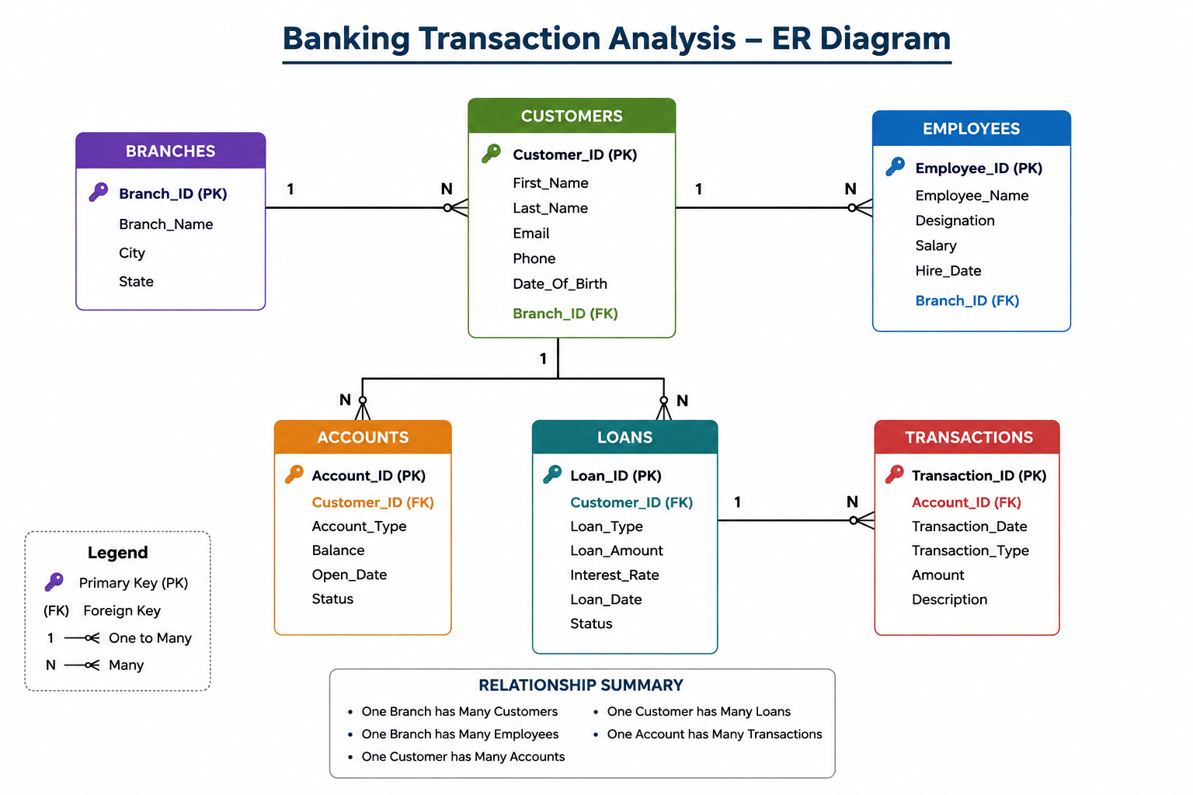

Relation Between Tables :
 | Child Table | Relationship
Branches | Customers | 1 : Many
Branches | Employees | 1 : Many
Customers | Accounts | 1 : Many
Customers | Loans | 1 : Many
Accounts | Transactions | 1 : Many

Tables
The Banking Transaction Analysis project consists of six relational tables designed to represent the major entities involved in a banking system.
Branches
The Branches table stores information about different bank branches.
Primary Key: Branch_ID
Main attributes:
- Branch_ID
- Branch_Name
- City
- State
Customers
The Customers table contains customer information and identifies the branch associated with each customer.
Primary Key: Customer_ID
Foreign Key: Branch_ID
Main attributes:
- Customer_ID
- First_Name
- Last_Name
- Branch_ID
- Other customer details
Accounts
The Accounts table stores information about customer bank accounts.
Primary Key: Account_ID
Foreign Key: Customer_ID
Main attributes:
- Account_ID
- Customer_ID
- Account_Type
- Balance
- Open_Date
- Status
Employees
The Employees table contains information about bank employees and their respective branches.
Primary Key: Employee_ID
Foreign Key: Branch_ID
Main attributes:
- Employee_ID
- Employee_Name
- Designation
- Salary
- Branch_ID
Loans
The Loans table stores information about loans taken by customers.
Primary Key: Loan_ID
Foreign Key: Customer_ID
Main attributes:
- Loan_ID
- Customer_ID
- Loan_Type
- Loan_Amount
- Interest_Rate
- Loan_Date
Transactions
The Transactions table stores financial transactions performed through customer accounts.
Primary Key: Transaction_ID
Foreign Key: Account_ID
Main attributes:
- Transaction_ID
- Account_ID
- Transaction_Date
- Transaction_Type
- Amount

SQL Concepts Used
The project uses a wide range of SQL concepts to perform banking data analysis.
Basic SQL
- SELECT
- WHERE
- DISTINCT
- ORDER BY
- LIMIT
Aggregate Functions
- COUNT()
- SUM()
- AVG()
- MIN()
- MAX()
Grouping
- GROUP BY
- HAVING
JOIN Operations
- INNER JOIN
- LEFT JOIN
- Multiple-table JOINs
Subqueries
- Single-row subqueries
- Multi-row subqueries
- Correlated subqueries
- IN
- NOT IN
Common Table Expressions
- WITH
- Multiple CTEs
- CTEs combined with aggregate functions
- CTEs combined with window functions
Window Functions
- ROW_NUMBER()
- RANK()
- DENSE_RANK()
- LAG()
- LEAD()
- FIRST_VALUE()
- LAST_VALUE()
- NTILE()
- PERCENT_RANK()
- SUM() OVER()
- AVG() OVER()
Date Functions
- YEAR()
- MONTH()
String Functions
- CONCAT()
These SQL concepts were applied to solve both technical SQL problems and real-world banking business problems.

INSIGHTS :
1-> The branch Kolkata central having branch_id 10 has the highest total balance(52,32,000)
2-> The customers took the highest loan amount by home loan .The loan is almost 3,66,50,000. The second highest loan amount if from car loan(85,50,000)
3-> All the cities have the same number of customers i.e.,10 customers
4-> Among all the branches , the employee from branch Kolkata_Central has the highest salary 94,000
5-> The highest total_Transaction Amount (1,76,50,656.00) has occurred in the month October 2024 .
6-> The customer Chaitanya Varma has the highest balance i.e.,10,12,000.
7-> There are 10 customers in each of the branches.
8-> In each branch , there are 4 employees.
9-> The customer Arjun Kumar has the highest loan amount 25,00,000.
10-> The customer Praveen Rao has the highest total transaction amount i.e.,48,71,000.
11-> In the current account ,maximum balance is 5,60,000. In the salary account , the maximum balance is 1,35,000 . In the fixed deposit account , the maximum balance is 9,10,000 . In the Savings account, the maximum balance is 1,71,000 .
12-> The branch Kolkata Central generating the highest total revenue
--->> 34973000
13-> The highest number of accounts are from savings account(63 accounts)
14-> The customer Rahul Sharma has the highest number of transactions ( 27 transactions ) .
15-> The branch Kolkata Central has the highest number of loans i.e., 9 loans .

Conclusion
The Banking Transaction Analysis Using SQL project successfully demonstrates how SQL can be used to analyze and extract meaningful insights from banking data.
The project analyzed data from 10 branches, 100 customers, 150 accounts, 40 employees, 50 loans, and 2,000 transactions. By connecting these related tables, the project provided a comprehensive view of customer behavior, account activity, transactions, loan distribution, and branch performance.
A wide range of SQL concepts was applied, including JOINs, aggregate functions, subqueries, Common Table Expressions (CTEs), and window functions. These techniques were used to answer real-world business questions such as identifying high-value customers, analyzing transaction trends, comparing branch performance, finding customers with multiple accounts or loans, and evaluating loan and account activity.
The project demonstrates that SQL is not only a tool for retrieving data but also a powerful language for business analysis and decision-making. The insights generated can help banking organizations improve customer retention, identify cross-selling opportunities, monitor branch performance, understand transaction behavior, and support data-driven business decisions.
Overall, this project provided practical experience in working with relational databases and solving real-world analytical problems using SQL. It also strengthened skills that are essential for a Data Analyst role, including data exploration, data aggregation, relational data analysis, and business-oriented problem solving.

